Installation of eclipse in MAC

- Navigate to https://www.eclipse.org/downloads/?osType=macosx

- Depending on the bit version,click on appropriate option

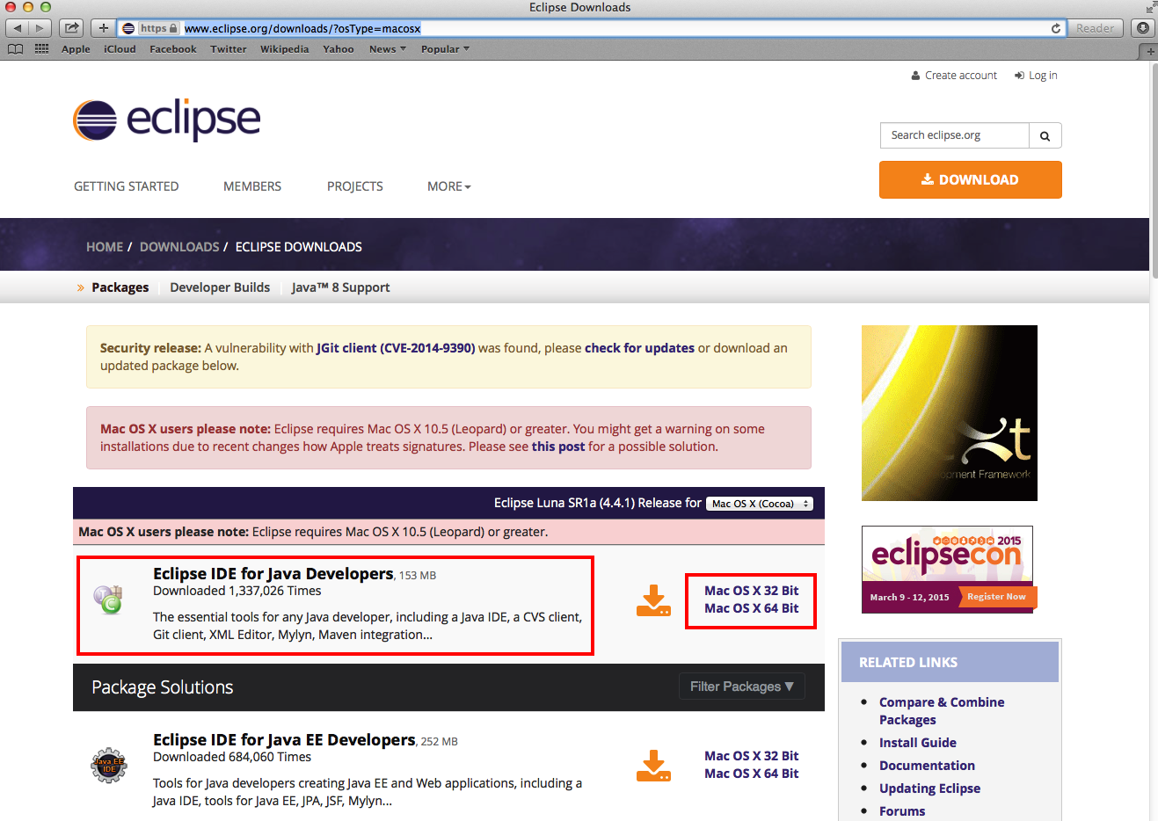

- Installs the required .tar file to downloads folder

- Now extract the .tar file to the required folder.

- Open that folder and double click on eclipse icon and start working with it
